

God’s plan is perfect and my plan is flawed, my narrow vision can not compare to the panoramic view that God holds.

Salvation is greater than any sin. There is no sin too great to be forgiven, but any sin can be a stumbling stone to your neighbor.



Love as God loves, without fear of rejection and without conditions. There is no greater feeling than to love and to be loved completely, wholly, and always.

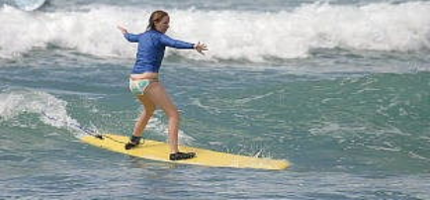
Consistency may be comforting but one can soon grow lethargic. “Learning is not attained by chance, it must be sought for with ardor and attended to with diligence.”- Abigail Adams


“Do not bear a grudge or seek revenge against one of your people. But love your neighbor as yourself. I am the Lord.” Leviticus 19:18

Mistakes are how we grow. Learn from them and let them go. You do not want to forget, but you can not dwell, laugh and move on.

Everyone makes mistakes, who but God is to say that one mistake is worse than another? Judgment can only be passed by Him who has not also made mistakes.
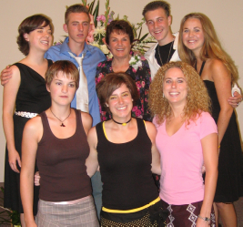

You are only as good as you feel. If you continue to give and give and never receive you will soon have nothing left. God wants us to give to others but He never said that we should suffer because of it.


A person that is secure in themselves will feel secure in a crowd or all alone. Comfort is found in strength of character not the strength of others.

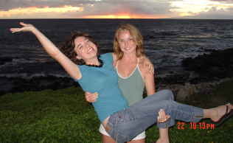
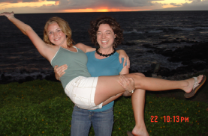
Sometimes you need to stand up and sometimes you need to walk away, you need strength to fight but also the knowledge and discernment to know when to quit.

A passion for life is greater than a passion for any object. When a person is truly happy they will not desire more, they will love more, laugh more, and live more. The key to life lies in the living it.


The world may not be perfect, but God still manages to bless it with beauty and grace. You can see Him in the rolling mountains, the crystal of the lakes, and hear His voice in the ocean. His unconditional love is shown in the soft eyes and cocked head of a beagle and His patience in the songbird waiting for sunrise.

“Kings take pleasure in honest lips; they value a man who speaks the truth.” Proverbs 16:13

“Never seem more learned than the people you are with. Do not pull it out to count the hours, but give the time when you are asked.” –Lord Chesterfield

Happiness is not a gift it is a choice. A hard day only turns “bad” if you let it. An unkind word can only get you down if you give in.


Words are meaningless. You can not only say that you are follower of God because that is not what he asks for. Mark 8:34 “If anyone would come after me, he must deny himself and take up his cross and follow Me.” It is and active choice.
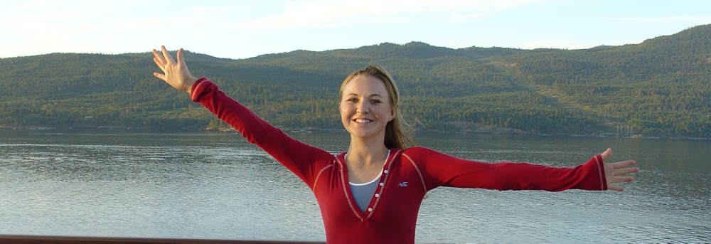
No one knows your boundaries better than you. No one knows your limits better than you. Just because others have failed doesn’t mean that you should not try.

“…Love your neighbor as yourself. There is no commandment better than these.” Mark 12:31

“I know what it is to be in need, and I know what it is to have plenty. I have learned the secret of being content in any and every situation, whether well fed or hungry, whether living in plenty or in want. I can do everything through Him who gives me strength.” Philippians 4:12-13

